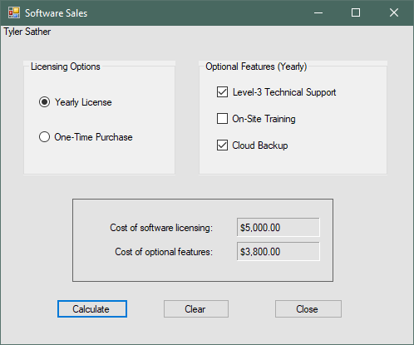

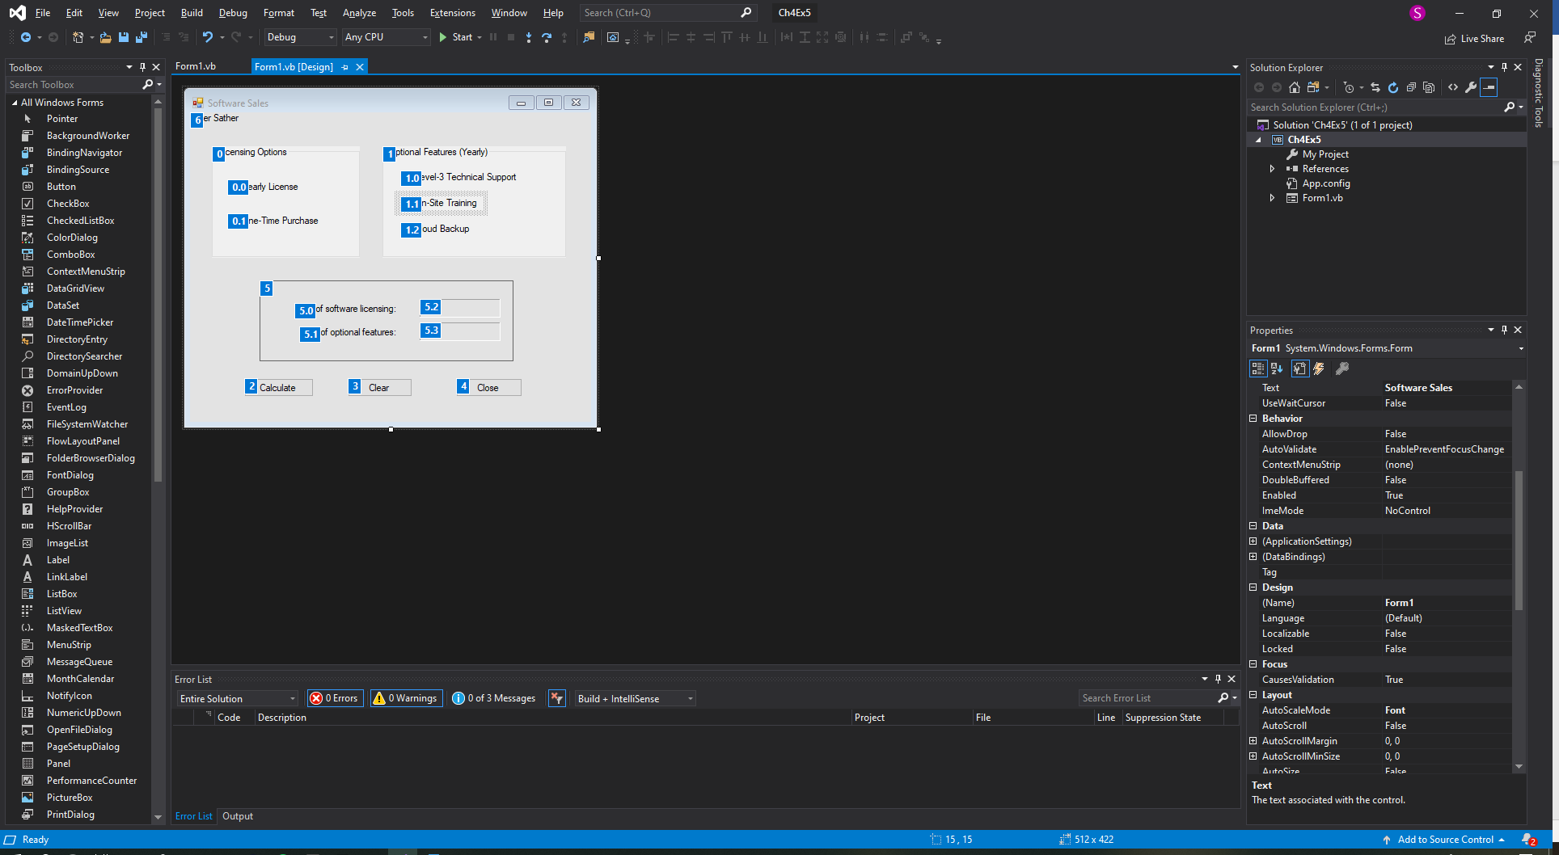

**********Main form Code

Public Class Form1

Private Sub btnCalc_Click(sender As Object, e As EventArgs) Handles btnCalc.Click

'Set my variables

Dim decSoftware As Decimal

Dim decOptional As Decimal = 0D

'Contants for Software Fees

Const decYear As Decimal = 5000D

Const decOne As Decimal = 20000D

'Constants for optional upgrades

Const decLevel As Decimal = 3500D

Const decOnSite As Decimal = 2000D

Const decCloud As Decimal = 300D

'Radial button code

If radYear.Checked = True Then

decSoftware = decYear

ElseIf radOne.Checked = True Then

decSoftware = decOne

End If

'Check box code

If chkLevel.Checked = True Then

decOptional += decLevel

End If

If chkOnSite.Checked = True Then

decOptional += decOnSite

End If

If chkCloud.Checked = True Then

decOptional += decCloud

End If

'Sends the output to my labels

lblSoftware.Text = decSoftware.ToString("c")

lblOptional.Text = decOptional.ToString("c")

End Sub

Private Sub btnClear_Click(sender As Object, e As EventArgs) Handles btnClear.Click

'Reset the Yearly Radial button

radYear.Checked = True

'Reset the Check Boxes

chkLevel.Checked = False

chkOnSite.Checked = False

chkCloud.Checked = False

'Clears the Output labels

lblSoftware.Text = String.Empty

lblOptional.Text = String.Empty

'Sends the tab back to the first radial Button

radYear.Focus()

End Sub

Private Sub btnClose_Click(sender As Object, e As EventArgs) Handles btnClose.Click

'Close the form

Me.Close()

End Sub

End Class